Registration Issue Fix
If you are faced with the issue of your registration not going through, follow these steps…
- CLOSE THE PROGRAM FIRST AND FOREMOST FOR THE CHANGES TO TAKE EFFECT

- Click on your Start button
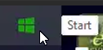
In the Search bar type in “REG” which should bring up this option seen below:
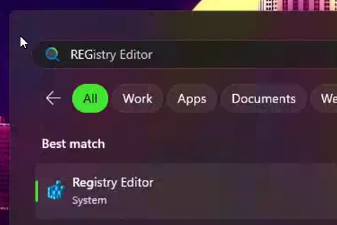
- Click on Registry Editor to open this box:
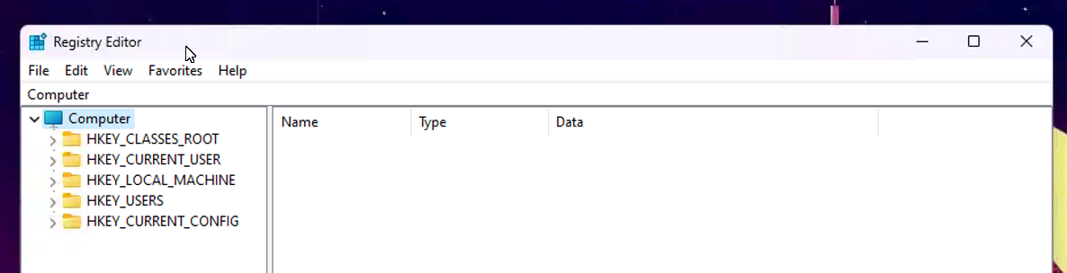

- Once open, you’ll click on the “HKEY_LOCAL_MACHINE” drop down menu
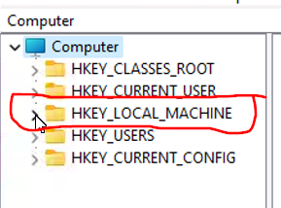
- In the LOCAL MACHINE drop down menu, you’ll click on “SOFTWARE”
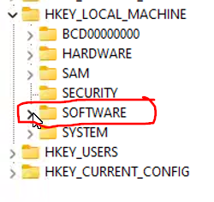
- In the SOFTWARE drop down menu, you’ll click on “WOW6432NODE”
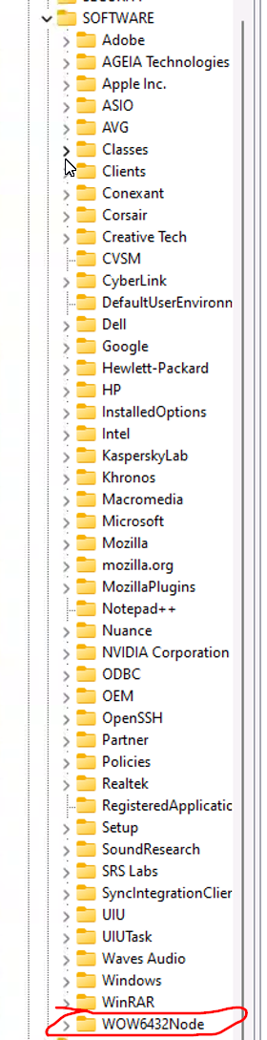
- In the WOW6432NODE drop down menu you’ll click on “AME Software”
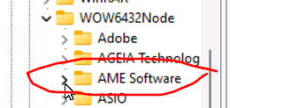
- In the AME Software folder you’ll find the “3.0” folder

Which should open up this box on the right hand side
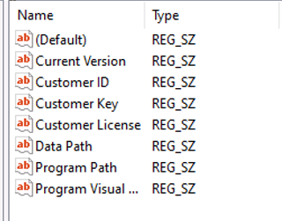
- Click on Customer ID to enter in your customer ID information
- Click on Customer Key to enter in the registration key

- After this point, exit out of the Registry Editor, and try to load the AME 3.0 program

- At this point, you should be successfully registered.

- IF YOU ARE STILL EXPERIENCING ISSUES PLEASE CONTACT
1-800-263-9455 FOR ADDITIONAL SUPPORT

IF the registration went through correctly, you’ll be greeted with your “Company List”

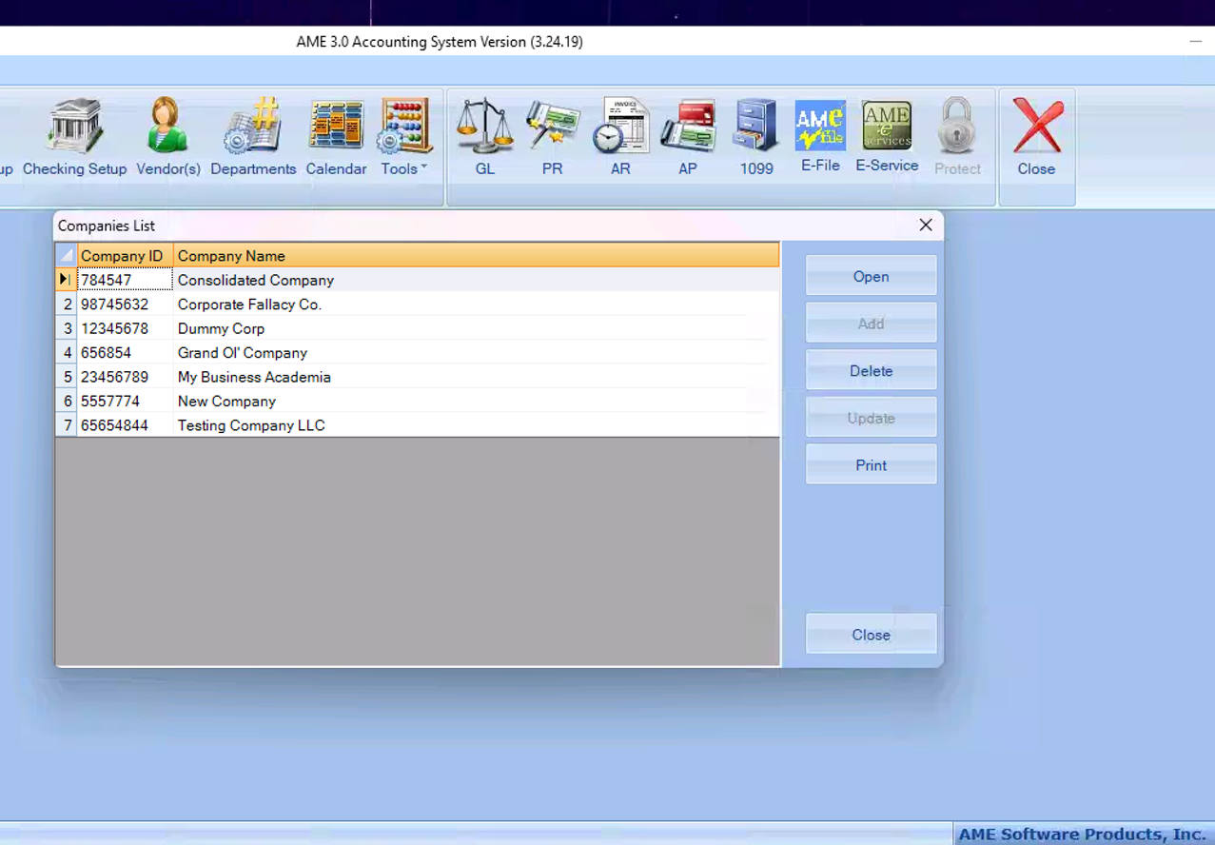
And you’re all good to go!

