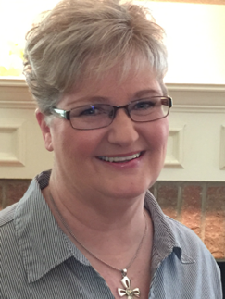

Biz On the Go
by Barbara E. Haley
haleybarb@yahoo.com
(XXX-XXX-XXXX)
www.barbarahaleybooks

Working Title: Biz On the Go — Book One of “A Second Wind” Series

Genre: Christian Women’s Contemporary Fiction

Length: Complete at 100,000 words

Availability: Immediately

Summary: Biz McNeely is forced to retire after managing a trucking company for over twenty-five years. She controls every relationship in her life until the day comes when family and friends pull away—unwilling to tolerate her critical interference any longer. Outspoken, driven, and used to working with men, Biz balks when she senses God leading her to reach out to the women of her church. She forges ahead but quickly realizes she must deny her controlling nature and learn to depend on God for direction. Biz On the Go will induce laughter and tears as you join this wacky, colorful group of middle-aged women in a fun-filled, emotionally charged drama of realistic life experiences. Beyond that, you will discover that while healthy and meaningful relationships require commitment, honesty, and self-sacrifice, the value of friendship is worth it all.

Endorsement: “Few authors can combine humor, faith and depth of emotion the way Barb Haley does. You will either see yourself in Biz—or wish she lived next door. Both Biz and Barb give us permission to embrace God’s love and be the women we were made to be.” Nancy Rue—author of over 200 books

Comparative Amazing Grace Adams by Fran Littlewood (2023)
Books: The Summer of You and Me by Denise Hunter (2024)
Healing Hearts by Crystal Lake (2024)

Biz On the Go is unique in that Biz moves beyond her own healing and second chance and reaches out to hurting teen girls going through similar hardships with unconditional love, grace, and encouragement.

Marketing: I have a website and blog at www.barbarahaleybooks.com. I am building my email newsletter and have 69 names at this time. I have 694 friends on Facebook and am becoming active on Pinterest. I have 15 team members who are dedicated to promoting my book on their social media. I am active in Scribbling Women Facebook Group, 540 Christian Writers Association, Author Media Social Group, and Write His Answer Facebook Group.

