DC POWER SUPPLY
Ningbo Kaijia Electronic Commerce Co., Ltd.
Address:Room 609, No. 18 Rikui Road, Jishigang,  Haishu District, Ningbo, China | （300W）

Telephone:+86 18757492227
vincent@jesverty.com

USER MANUAL

CONTENTS
SAFETY BRIEF 1
SAFETY SYMBOL 1
PRODUCT BRIEF 2
SPECIFICATION 3
PANEL INSTRUCTION 4
WORK REQUIEMENT 5
OPERATION INSTRUCTION 5
CONNECT THE LOAD 6
CONSTANT VOLTAGE/CONSTANT 6
CURRENT CHARACTERISTICS
FUSE REPLACEMENT 7
PRODUCT MAINTENANCE 8
PRODUCT WARRANTY 8
PACKING LIST 8


SAFETY BRIEF PRODUCT BRIEF

This manual contains important safety instructions that must be followed in the operation and storage environment of theSPS-3005 /3010/6005/12003 series. To ensure your personal safety, and ensures that this product works in the best environment,please read this manual carefully before using.
When you get a brand-new power supply, you need to do the necessary checks to make sure the instrument is working properly.
1. To check whether there are damages caused during transportation.
2. To check whether all the accessories are complete.
3.To check whether the output voltage and output current are normal after turning on the device.
If finding out any problems, please contact the merchant immediately.
SAFETY SYMBOL
The safety symbols below will appear in this manual or on the DC power supply.
!     | Attention  High Voltage  Grounding
1

The SPS-3005/3010/6005/12003 series of adjustable
regulated DC power supply designed for use in laboratories, schools and production lines. Both output voltage and
output current arecontinuously adjustable between 0 and nominal.
The stability and ripple factor of the power supply are very good and have a perfect protection circuit. Can work at full load for a long time. This power supply can be used as both a regulated power supply and a regulated current supply.
2






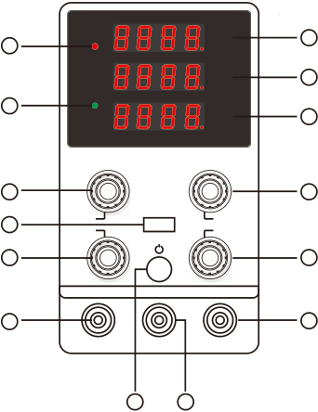
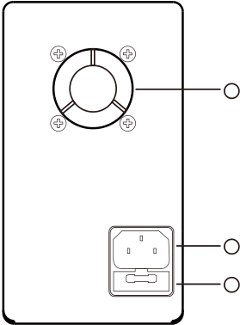
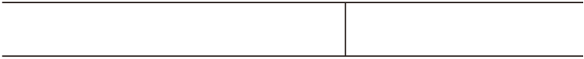
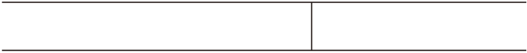








SPECIFICATION |  |  |  |  | PANEL INSTRUCTION： |  |  |  |  |  |  | 1 | Output Voltage Display
1.Switchable DC regulated power supply |  |  |  |  |  |  |  |  |  |  |  | 1 | Output Voltage Display
 |  |  |  |  |  |  |  |  |  |  |  | 2 | Output Current Display
Model Number | SPS-3005 | SPS-3010 | SPS-6005 | SPS-12003 | 4 |  | C.V | V |  |  | 1 | 3 | Output Power Display
 |  |  |  |  | A |  |  |  |  |  | 2 | 4 | Voltage Regulator
Output Voltage | 0-30V | 0-30V | 0-60V | 0-120V | 5 |  | C.C | W |  |  | 3 | 5 | Voltage Regulator
 |  |  |  |  |  |  |  |  |  |  |  |  | Current Regulator
Output Current | 0-5A | 0-10A | 0-5A | 0-3A
 |  |  |  |  |  |  |  |  |  |  |  | 6 | Voltage Coarse Tuner
Input Voltage: AC110V 60Hz
Working Temperature: 0℃～40℃；Relative Humidity:＜80%RH |  |  |  |  | 8 |  |  | 6 |  |  |  | 7 | Current Coarse Tuner
Storage Temperature: -10℃～70℃;Relative Humidity:＜70%RH |  |  |  |  | 10 | V-FINE |  | 5V/2A |  | V-COARSE |  | 8 | Voltage Fine Tuner
 |  |  |  |  | 10 | A-FINE |  |  |  | A-COARSE |  | 8 | Voltage Fine Tuner
Constant Voltage State:Voltage stability≤0.1%±3mV |  |  | Voltage stability≤0.2%±3mV |  | 9 |  |  | 7 |  |  |  | 9 | Current Fine Tuner
Low voltage:0.2～0.3%±3mV |  |  | Low voltage:0.3～0.4%±3mV
 |  |  |  |  |  |  |  |  |  |  |  | 10 | USB Charging Socket(2A)
Load stability≤0.5%±3mV |  |  |  |  | 13 |  |  | 11 |  |  |  | 11 | Positive Polarity(red)
Ripple noise≤10mVrms  ≤150mVp-p |  |  | Ripple noise≤150mVp-p |  | - |  |  | GND |  | + |  | 11 | Positive Polarity(red)
 |  |  |  |  |  |  |  |  |  |  |  | 12 | Grounding(green)
 |  |  |  |  | 14 |  |  |  | 12 |  |  | 13 | Negative Polarity (black)
Constant Current State:Current stability≤0.2%±3mA
 |  |  |  |  |  |  |  |  |  |  |  | 14 | Power Switch
Load stability≤0.2%±3mA
Ripple noise≤20mArms
Display Accuracy:0.5%±2digits
Display Resolution:Voltage:00.01V/0.01V Current:0.001A/0.01A
Product Dimension:220×85×150mm(L×W×H）
Product Weight:1.4Kg |  |  |  |  | USE ONLY WITH 250V FUSE | 15 | 4 | 15 | Cooling Fan
Fuse Standard | T6A | T8A | T8A | T8A
The above parameters are measured at an ambient
 |  |  |  |  |  |  |  | 16 | Power Socket
temperature of 25±5°C,relative humidity: <80%RH,and
preheated for 30 minutes. The actual parameters will vary |  |  |  |  | USE ONLY WITH 250V FUSE | 16 | 4 | 17 | Fuse Box
slightly.
3 |  |  |  |  | USE ONLY WITH 250V FUSE | 17 | 4 | 17 | Fuse Box

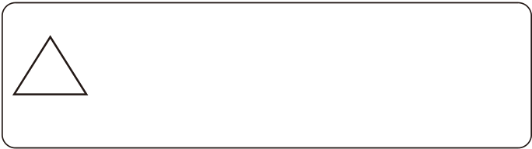
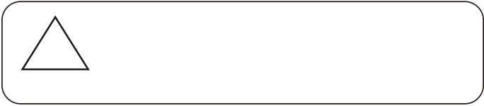
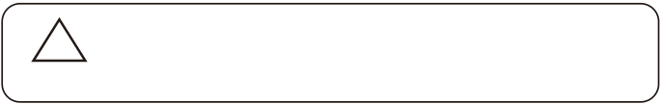
WORK REQUIEMENT | ! | In actual CV operation, if the load resistance decreases and the
1、AC input: Please make sure the input voltage of this product | ! | output current increases to the set current value, the power supply
 | ! | will automatically switch to CC mode.When the load resistance
 | ! | value continues to decrease, the current will remain at the current
AC110V 60Hz | !
AC110V 60Hz | ! | set value.The voltage is proportionally reduced. At this time,
2、Do not use in an environment where the ambient temperature | Attention | increase the load resistance or increase the current set value to
2、Do not use in an environment where the ambient temperature | Attention | restore the CV output state.
exceeds 40 degrees Celsius. The cooling fan is located at the | Attention | restore the CV output state.
rear of the device and should have enough space for cooling.
! | Incorrect AC voltage input will cause serious damage | CONNECT THE LOAD
! | Incorrect AC voltage input will cause serious damage | 1. Rotate the terminal knob by turning it counterclockwise
! | to the device. Please make sure the required input | 1. Rotate the terminal knob by turning it counterclockwise
Warring | voltage value. | 1. Rotate the terminal knob by turning it counterclockwise
Warring | voltage value. | 2. Insert the load terminal
3.Turn the terminal knob clockwise

Warring：Incorrect AC voltage input will cause serious damage
to the device. Please make sure the required input voltage value.
OPERATION INSTRUCTION
There are two types of power output modes: constant voltage output (CV) and constant current output (CC). The output mode is determined by the voltage and current values set by the user and the load connected by the user. The output voltage or
current value of the power supply won't exceed the voltage and current values set by the user. In constant voltage mode, the output voltage value is equal to the user-set voltage value. In constant current mode, the output current value is equal to the user-set current value.
For example: the voltage value is set to 5V and the current value is set to 5A.
Steps
1. Turn on the power switch
2. Adjust the voltage adjustment knob to 5V
3.Connect the "positive" and "negative"with wires and adjust the current knob to 5A.
4. Disconnect the wire and connect the load to use.

4. Banana plug can be directly inserted into the terminal hole
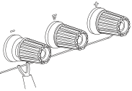 |  | 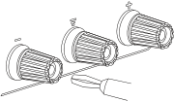
!  Attention | Improper connection may result in damage to the power supply and the load connected to the power supply.When connecting the battery load, do not reverse the polarity of the “+” and “-" as this may damage the power supply.
CONSTANT VOLTAGE/CONSTANT CURRENT CHARACTERISTICS
The working characteristics of this series of power supplies are constant voltage/constant current automatic conversion type, which can automatically change between constant voltage and constant current states with load changes. The intersection between constant voltage and constant current mode is called conversion point.For example, if the load causes the power supply to operate in a constant voltage mode, a constant voltage is output. As the load increases, the output voltage will remain constant and the output current will increase.When the current value reaches the set current limit value, the power supply will

5 6

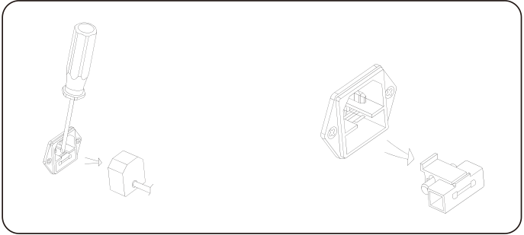
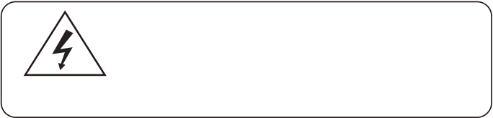
automatically switch to constant current mode. The output

current remains stable and the output voltage decreases
proportionally as the load increases further.The conversion of constant voltage and constant current is indicated by the LED on the front panel.
CV indicator light is on during constant voltage, CC indicator is on when constant current.
FUSE REPLACEMENT
If the fuse blows, the power supply will stop working.To find and correct the cause of the blown fuse, then replace it with a fuse of the same specification.
Replace the fuse of same
specification,then put the fuse
cabin back.
Remove the power plug first,then open
the fuse cabin according to the
illustration.
Fuse cabin is in the power socket
For effective safety protection, it is only necessary to
4replace the fuse of a specific specification. Before replacing the fuse,the power must be turned off and the
HIGH VOLTAGE!  DANGER! | power cord must be unplugged from the power outlet.
7

PRODUCT MAINTANCE
1.Disconnect the power when the product is not in use.
2.Unplug the power supply before cleaning.
3. Do not use hydrocarbons, chlorides or similar solvents,or use abrasive cleaners.
PRODUCT WARRANTY
1. This product is offered free maintenance service within one year from the date of purchase. Except in the following cases:
A:Failures caused by improper use, such as improper handling and improper repair, modification or adjustment of the device.
B:Consumable materials are not covered by the warranty.
C:Naturally irresistible disasters such as floods, fires,earthquakes,etc.
2. Maintenance costs are charged for repairs that exceed the warranty period,and the costs incurred for maintenance are the responsibility of the user.
PACKING LIST
1. 1x Power Supply
2.1x Power Cord
3. 1x Output Load Cord
4.1x User's Manual
8

