HOW TO LOOK AT YOUR COMPANY VEHICLE LISTING ON WE REPORTING

- Go to WEPORTAL.COM
- Click the WE REPORTING quick link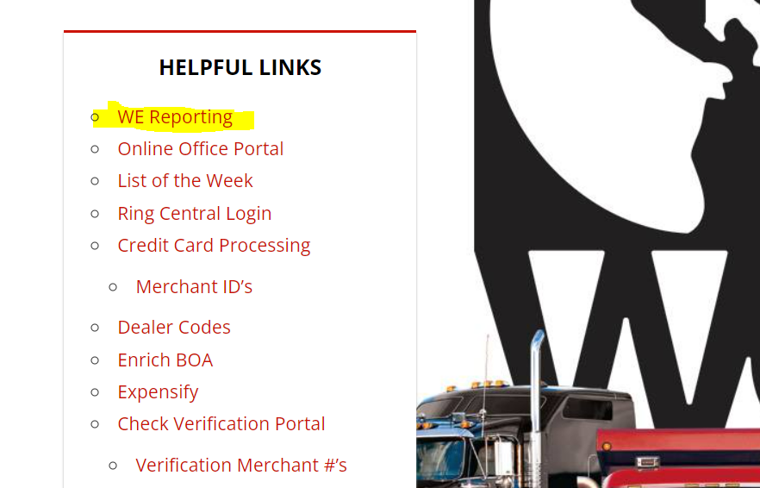
- Log in : Username = Fusion Username Password = ReportingXXXX (XXXX will be the last four of your SSN. Example Reporting1234)
- Click on the Accounting folder
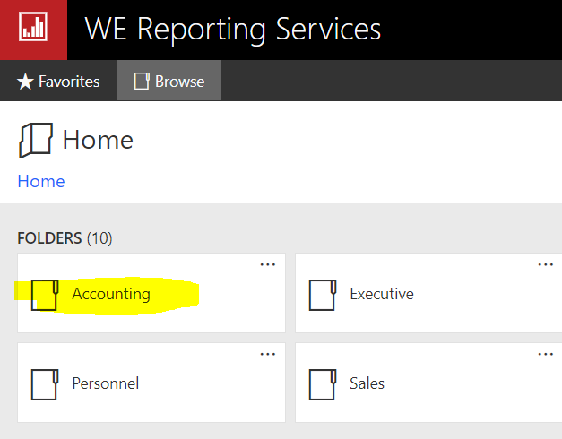
- Click on Company Vehicle Listing to view the report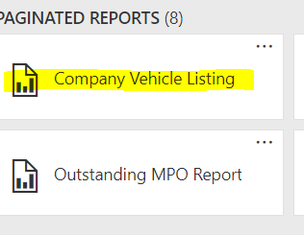
- You will need to select the branch you would like to view the report for
  - You will only have branches listed that you have access to in Fusion.
  - You will also be able to filter by Unit Status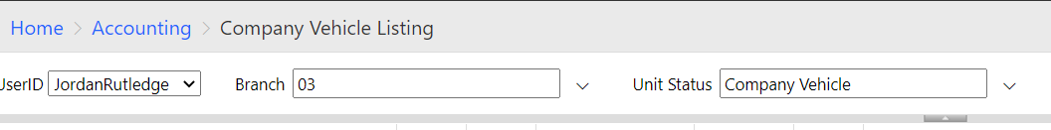
- Select View Report
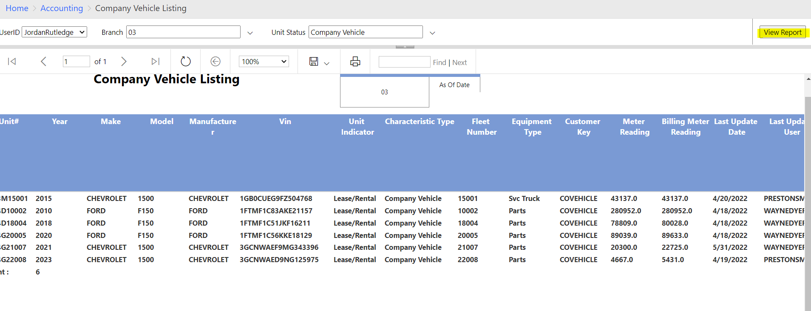

Company Vehicle unit # break down:

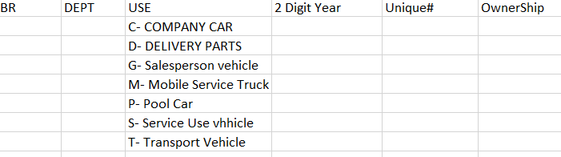

Example: 0304D15001
Branch 03/Dept Parts/Delivery Parts/2015/001

