CURRICULUM VITAE (CV)
Personal Information:
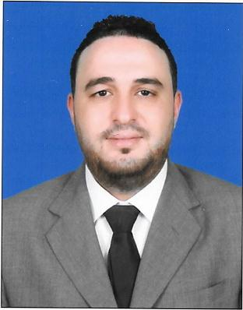
Name: LAHMEDI WISSEM
Date of Birth: 16/10/1992
Nationality: Tunisian
Address : Doha / Qatar
Phone number: 33942842
Email: Lahmediwissem.1@gmail.com
Family Status: Single
Valid Working QID with NOC
Qatari Driving license .

Objective:

-Achieve my goals Step by step
-Access to my professional dream through sacrifice and effort at work and win the love
Of all colleagues and customer
-To obtain a position at a reputable company where I can maximize my
management skills ,quality assurance and program development.
I am eager to learn , I enjoy overcoming challenges, and I am a responsible,
intelligent and experienced retail professional with an extensive background in
both retail and sales in large boutiques.

Key Skills:
-Communication – Deals with internal and external customers at all levels via
Telephone and email, to ensure successful communication via actively listening
And probing questions.
-Problem Solving -Approach the problem with external and internal business
Partners to find the appropriate solutions.
-Team player – Enjoys sharing knowledge and encouraging development of
Others to achieve specific team goals.
-Planning and organizing -Refined planning and organizational skills that
Balance work, team support and assign responsibilities in a timely and professional
Manner.
-Systems knowledge- Microsoft Office, Excel , Outlook and internet.

-Good experience in Sales and Marketing
-The account on the Cashier machine is very perfect
- Experience in selling products and convincing the customer to buy them
- Experience in arranging , accounting and organizing the Items in ware house and Shops .

-All conditions of group or individual work at what Time .
-Dealing professionally with different people and implementing and carrying out immediately all their requests and wishes .

Professional Experience:
Position:

- GENERAL MANAGER : MELLISIA ABAYA SHOP . FESTIVAL CITY 2023/2024

-Beauty advisor: Watson’s Showroom Festival city mall 2022. Al Futtaim group

-Sales Representative : Salesman in Al Muftah.group center 2019..2021 electronics house products and Home appliances

-Sales Assistant in Toys R Us Al SAAD : In Al Futtaim group
January 2018 - Mars 2019

-Music Teatcher In private School 2015 -2016

-Supervisor: in "GRAÊT Company" for electronic house products 2011- 2012

-Sales Representative and Promoter in a Branch Unilever Company
Monastir 2010 -2011 “ UNILEVER “ Branch Tunisia ( COCA COLA , OMO,KNOR
SINSILK, KAJOLINE ….)

Languages :
-Arabic : Mother language
-English : Very good reading , writing and speaking.
-French : Very good reading , writing and speaking.

Education:
-High School Baccalaureate degree - Economics ( Graduated in 2011).
-Degree in Computer Sience
-Degree in Arabic Musique : University Degree majoring in Arabic Music Piano
-General English Certificate (Diploma)in Institute KSAR HLEL language Graduated in 2014 / Course for 1 Years

- Customs formalities Technicians in private university INFO 2000 Tunisia With Experience .

References are available upon request

