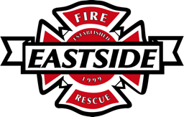

FIRE CHIEF RECRUITMENT
Candidate Supplemental Questions

In order for Eastside Fire & Rescue to get a better sense of your communication skills and experience, please answer the following questions. Kindly limit your answers to one page.

1) Tell us why you are interested in this position and what you bring to the table as the next fire chief for Eastside Fire & Rescue?

2) What is your experience of engaging successfully with multiple jurisdictions within your previous region?

3) How will you inspire the organization in a shared vision for the future?

