Server Import Walkthrough
In this guide we’ll go through the process of Getting your 2.0 company information into the import list from a server when you see a blank import screen.
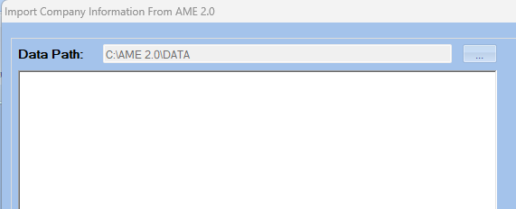

If you go to import your companies and you are greeted with a blank screen, “No Database can be found”, or you can NOT find your server from the drop-down menu provided, then follow these steps:
Click on your File Explorer
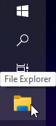 Then click on your Windows (C:) 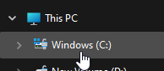
Navigate to the Ame 3.0 Folder 
Scroll down until you see the “oldpath(TXT)” file. And double click on it
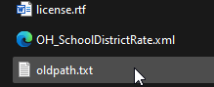
Which will pop open a txt document.
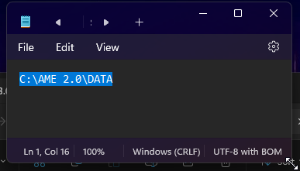
Change the C:\AME to the location of your 2.0 data on the server.
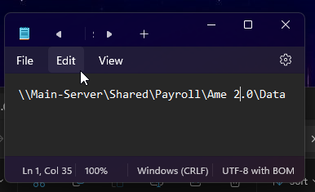
Now Navigate back to the Import menu for 3.0 and your 2.0 company list should be there!
